Code:

import tensorflow as tf

import tensorflow_hub as hub

import matplotlib.pyplot as plt

import numpy as np

import pandas as pd

import seaborn as sns

from tensorflow.keras.utils import get_file

from sklearn.metrics import roc_curve, auc, confusion_matrix

from imblearn.metrics import sensitivity_score, specificity_score

import os

import glob

import zipfile

import random

# to get consistent results after multiple runs

tf.random.set_seed(7)

np.random.seed(7)

random.seed(7)

# 0 for benign, 1 for malignant

class_names = ["benign", "malignant"]

def download_and_extract_dataset():

  # dataset from https://github.com/udacity/dermatologist-ai

  # 5.3GB

  train_url = "https://s3-us-west-1.amazonaws.com/udacity-dlnfd/datasets/skin-cancer/train.zip"

  # 824.5MB

  valid_url = "https://s3-us-west-1.amazonaws.com/udacity-dlnfd/datasets/skin-cancer/valid.zip"

  # 5.1GB

  test_url  = "https://s3-us-west-1.amazonaws.com/udacity-dlnfd/datasets/skin-cancer/test.zip"

  for i, download_link in enumerate([valid_url, train_url, test_url]):

    temp_file = f"temp{i}.zip"

    data_dir = get_file(origin=download_link, fname=os.path.join(os.getcwd(), temp_file))

    print("Extracting", download_link)

    with zipfile.ZipFile(data_dir, "r") as z:

      z.extractall("data")

    # remove the temp file

    os.remove(temp_file)

# comment the below line if you already downloaded the dataset

download_and_extract_dataset()

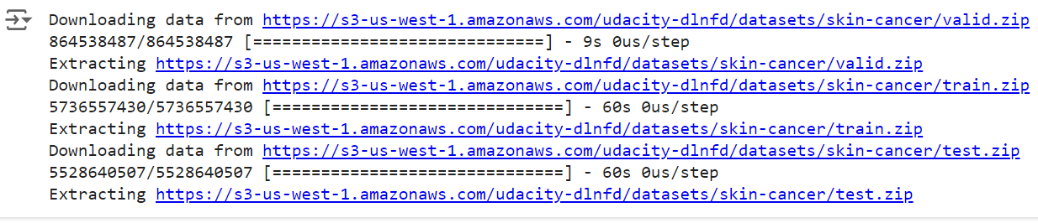

# preparing data

# generate CSV metadata file to read img paths and labels from it

def generate_csv(folder, label2int):

    folder_name = os.path.basename(folder)

    labels = list(label2int)

    # generate CSV file

    df = pd.DataFrame(columns=["filepath", "label"])

    i = 0

    for label in labels:

        print("Reading", os.path.join(folder, label, "*"))

        for filepath in glob.glob(os.path.join(folder, label, "*")):

            df.loc[i] = [filepath, label2int[label]]

            i += 1

    output_file = f"{folder_name}.csv"

    print("Saving", output_file)

    df.to_csv(output_file)

# generate CSV files for all data portions, labeling nevus and seborrheic keratosis

# as 0 (benign), and melanoma as 1 (malignant)

# you should replace "data" path to your extracted dataset path

# don't replace if you used download_and_extract_dataset() function

generate_csv("data/train", {"nevus": 0, "seborrheic_keratosis": 0, "melanoma": 1})

generate_csv("data/valid", {"nevus": 0, "seborrheic_keratosis": 0, "melanoma": 1})

generate_csv("data/test", {"nevus": 0, "seborrheic_keratosis": 0, "melanoma": 1})

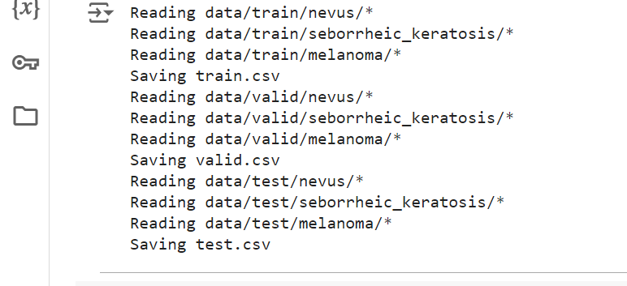

# loading data

train_metadata_filename = "train.csv"

valid_metadata_filename = "valid.csv"

# load CSV files as DataFrames

df_train = pd.read_csv(train_metadata_filename)

df_valid = pd.read_csv(valid_metadata_filename)

n_training_samples = len(df_train)

n_validation_samples = len(df_valid)

print("Number of training samples:", n_training_samples)

print("Number of validation samples:", n_validation_samples)

train_ds = tf.data.Dataset.from_tensor_slices((df_train["filepath"], df_train["label"]))

valid_ds = tf.data.Dataset.from_tensor_slices((df_valid["filepath"], df_valid["label"]))

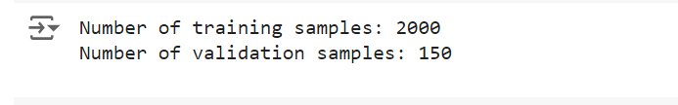

# preprocess data

def decode_img(img):

  # convert the compressed string to a 3D uint8 tensor

  img = tf.image.decode_jpeg(img, channels=3)

  # Use `convert_image_dtype` to convert to floats in the [0,1] range.

  img = tf.image.convert_image_dtype(img, tf.float32)

  # resize the image to the desired size.

  return tf.image.resize(img, [299, 299])

def process_path(filepath, label):

  # load the raw data from the file as a string

  img = tf.io.read_file(filepath)

  img = decode_img(img)

  return img, label

valid_ds = valid_ds.map(process_path)

train_ds = train_ds.map(process_path)

# test_ds = test_ds

for image, label in train_ds.take(1):

    print("Image shape:", image.shape)

    print("Label:", label.numpy())



# training parameters

batch_size = 64

optimizer = "rmsprop"

def prepare_for_training(ds, cache=True, batch_size=64, shuffle_buffer_size=1000):

  if cache:

    if isinstance(cache, str):

      ds = ds.cache(cache)

    else:

      ds = ds.cache()

  # shuffle the dataset

  ds = ds.shuffle(buffer_size=shuffle_buffer_size)

  # Repeat forever

  ds = ds.repeat()

  # split to batches

  ds = ds.batch(batch_size)

  # `prefetch` lets the dataset fetch batches in the background while the model

  # is training.

  ds = ds.prefetch(buffer_size=tf.data.experimental.AUTOTUNE)

  return ds

valid_ds = prepare_for_training(valid_ds, batch_size=batch_size, cache="valid-cached-data")

train_ds = prepare_for_training(train_ds, batch_size=batch_size, cache="train-cached-data")

batch = next(iter(valid_ds))

def show_batch(batch):

  plt.figure(figsize=(12,12))

  for n in range(25):

      ax = plt.subplot(5,5,n+1)

      plt.imshow(batch[0][n])

      plt.title(class_names[batch[1][n].numpy()].title())

      plt.axis('off')

show_batch(batch)

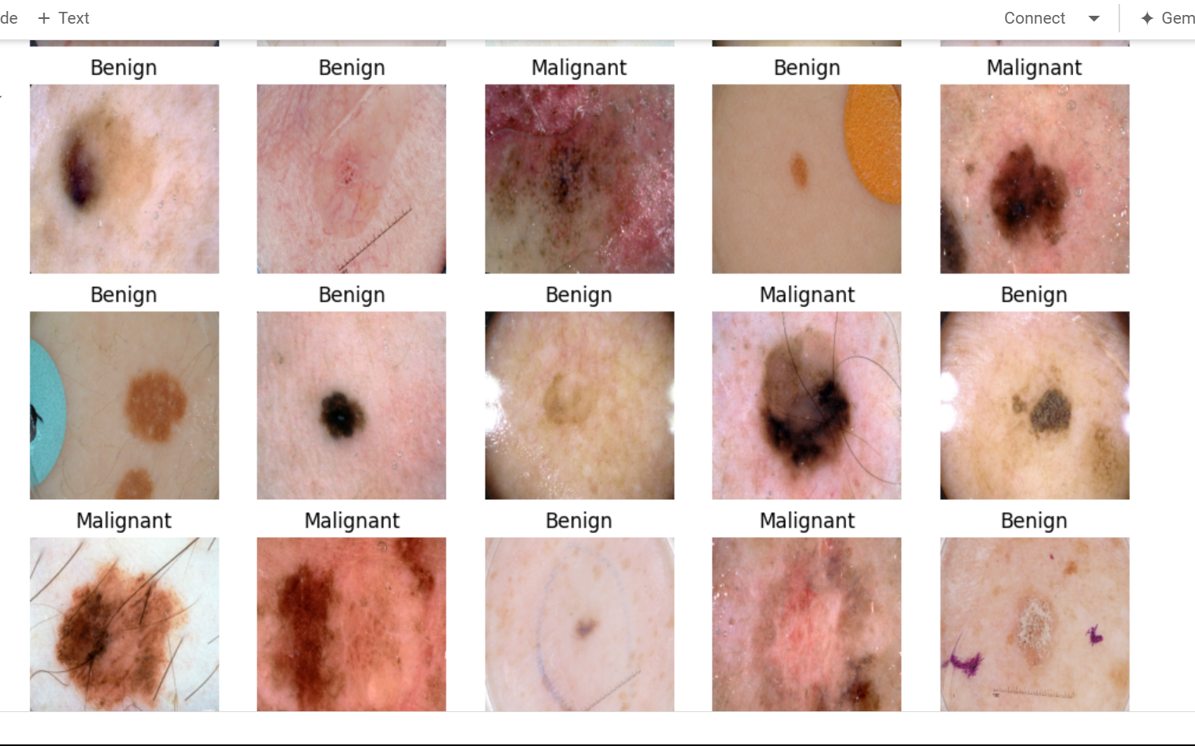

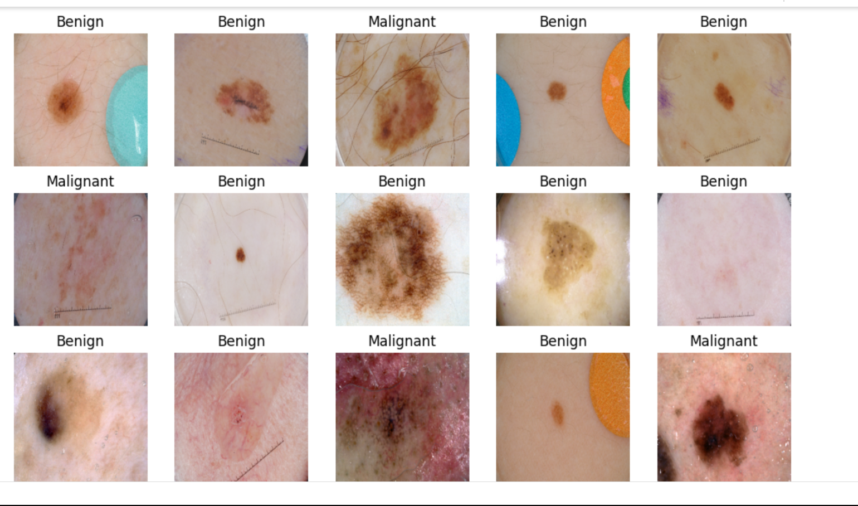

# building the model

# InceptionV3 model & pre-trained weights

module_url = "https://tfhub.dev/google/tf2-preview/inception_v3/feature_vector/4"

m = tf.keras.Sequential([

    hub.KerasLayer(module_url, output_shape=[2048], trainable=False),

    tf.keras.layers.Dense(1, activation="sigmoid")

])

m.build([None, 299, 299, 3])

m.compile(loss="binary_crossentropy", optimizer=optimizer, metrics=["accuracy"])

m.summary()

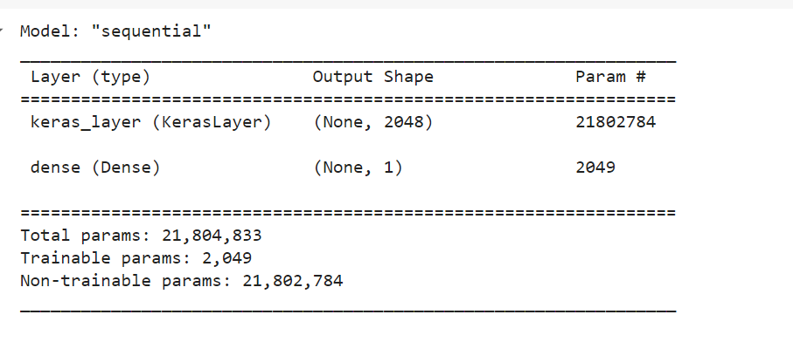

model_name = f"benign-vs-malignant_{batch_size}_{optimizer}"

tensorboard = tf.keras.callbacks.TensorBoard(log_dir=os.path.join("logs", model_name))

# saves model checkpoint whenever we reach better weights

modelcheckpoint = tf.keras.callbacks.ModelCheckpoint(model_name + "_{val_loss:.3f}.h5", save_best_only=True, verbose=1)

history = m.fit(train_ds, validation_data=valid_ds,

                steps_per_epoch=n_training_samples // batch_size,

                validation_steps=n_validation_samples // batch_size, verbose=1, epochs=65,

                callbacks=[tensorboard, modelcheckpoint])

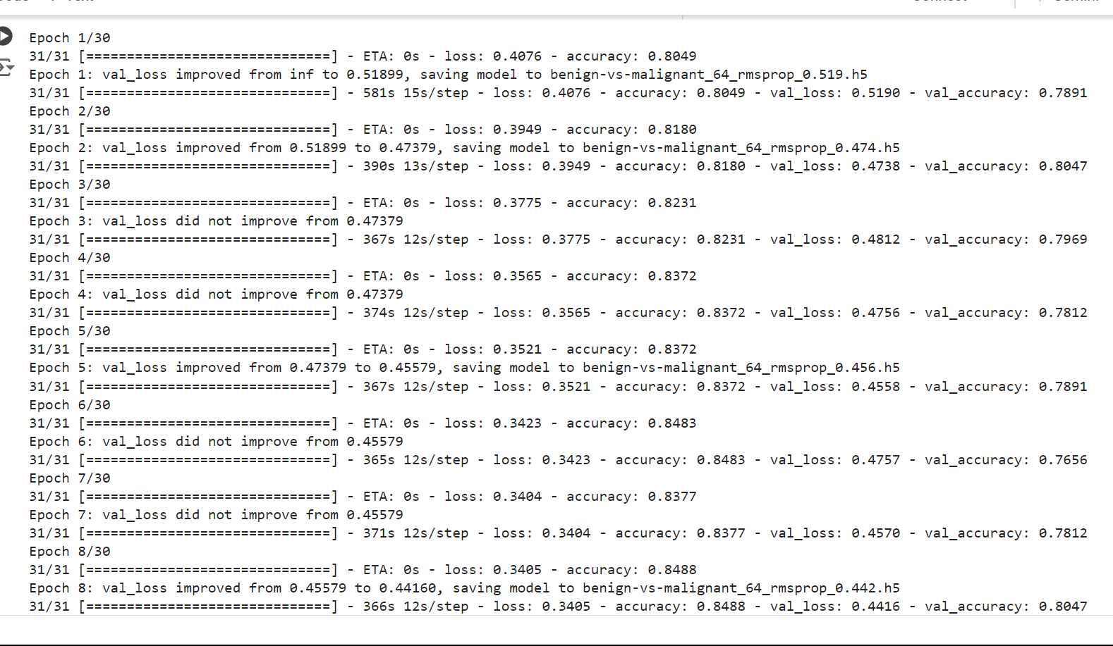

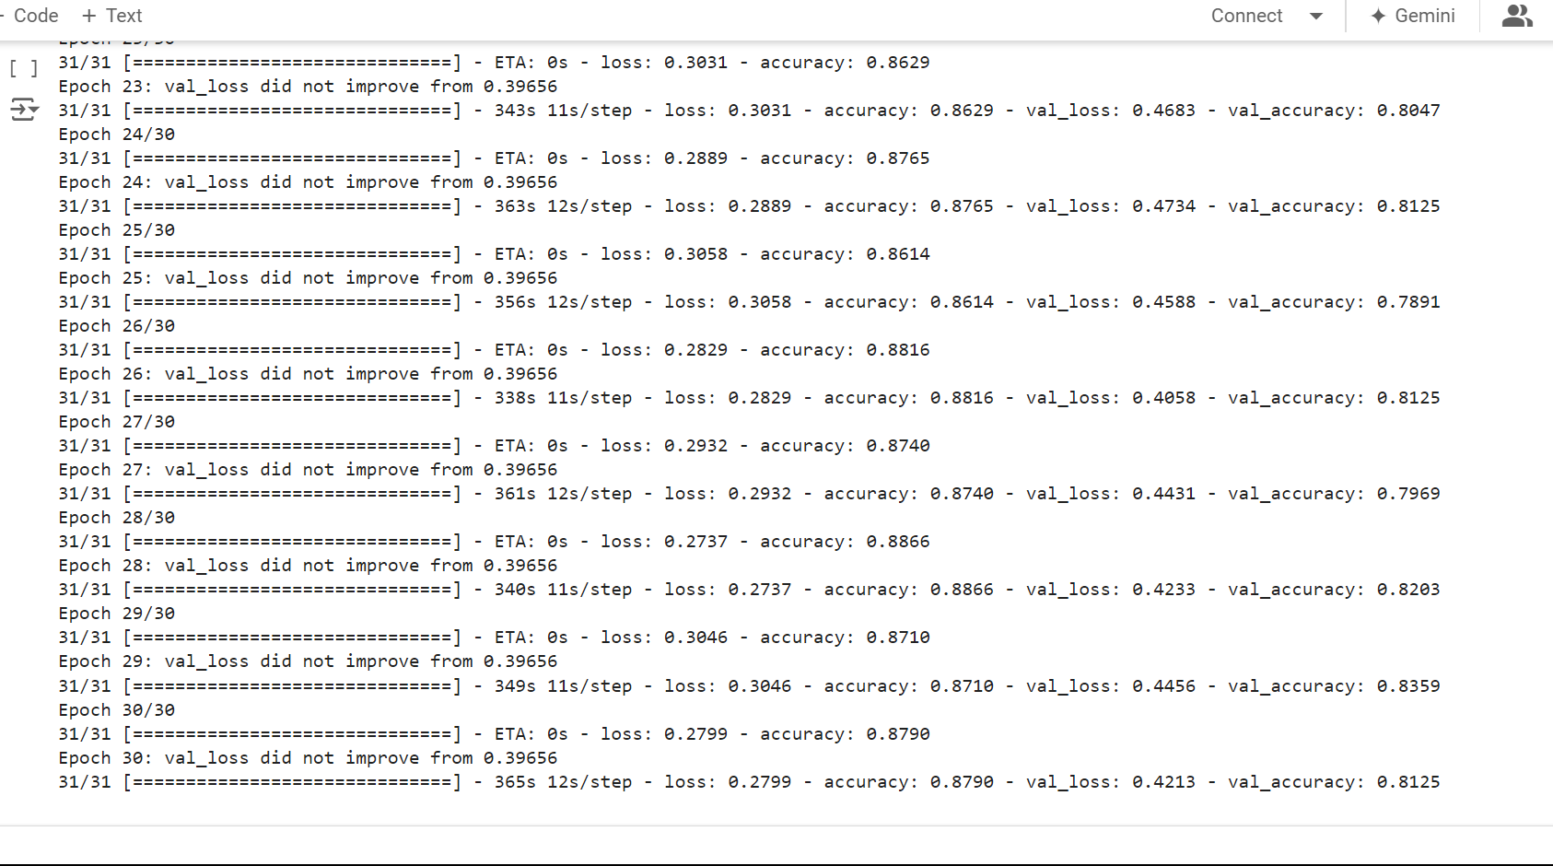

# convert testing set to numpy array to fit in memory (don't do that when testing

# set is too large)

y_test = np.zeros((n_testing_samples,))

X_test = np.zeros((n_testing_samples, 299, 299, 3))

for i, (img, label) in enumerate(test_ds.take(n_testing_samples)):

  # print(img.shape, label.shape)

  X_test[i] = img

  y_test[i] = label.numpy()

print("y_test.shape:", y_test.shape)

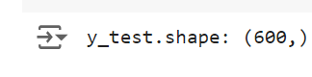

# load the weights with the least loss

m.load_weights("benign-vs-malignant_64_rmsprop_0.396.h5")

print("Evaluating the model...")

loss, accuracy = m.evaluate(X_test, y_test, verbose=0)

print("Loss:", loss, "  Accuracy:", accuracy)

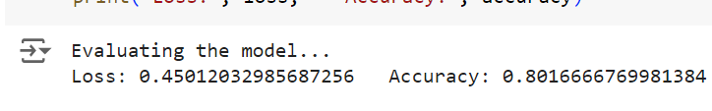

def get_predictions(threshold=None):

  """

  Returns predictions for binary classification given `threshold`

  For instance, if threshold is 0.3, then it'll output 1 (malignant) for that sample if

  the probability of 1 is 30% or more (instead of 50%)

  """

  y_pred = m.predict(X_test)

  if not threshold:

    threshold = 0.5

  result = np.zeros((n_testing_samples,))

  for i in range(n_testing_samples):

    # test melanoma probability

    if y_pred[i][0] >= threshold:

      result[i] = 1

    # else, it's 0 (benign)

  return result

threshold = 0.23

# get predictions with 23% threshold

# which means if the model is 23% sure or more that is malignant,

# it's assigned as malignant, otherwise it's benign

y_pred = get_predictions(threshold)

def plot_confusion_matrix(y_test, y_pred):

  cmn = confusion_matrix(y_test, y_pred)

  # Normalise

  cmn = cmn.astype('float') / cmn.sum(axis=1)[:, np.newaxis]

  # print it

  print(cmn)

  fig, ax = plt.subplots(figsize=(10,10))

  sns.heatmap(cmn, annot=True, fmt='.2f',

              xticklabels=[f"pred_{c}" for c in class_names],

              yticklabels=[f"true_{c}" for c in class_names],

              cmap="Blues"

              )

  plt.ylabel('Actual')

  plt.xlabel('Predicted')

  # plot the resulting confusion matrix

  plt.show()

plot_confusion_matrix(y_test, y_pred)

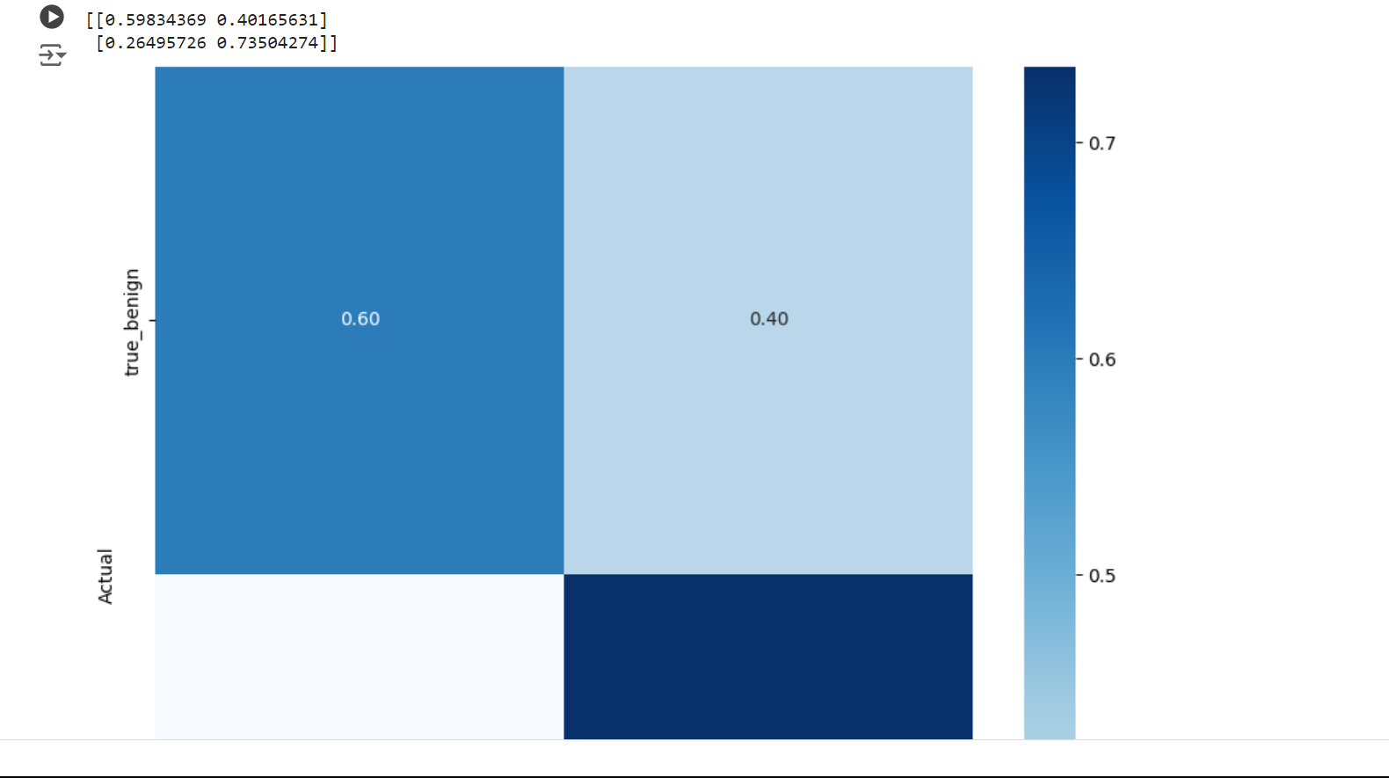

sensitivity = sensitivity_score(y_test, y_pred)

specificity = specificity_score(y_test, y_pred)

print("Melanoma Sensitivity:", sensitivity)

print("Melanoma Specificity:", specificity)

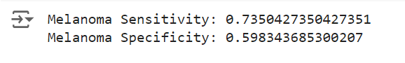

def plot_roc_auc(y_true, y_pred):

    """

    This function plots the ROC curves and provides the scores.

    """

    # prepare for figure

    plt.figure()

    fpr, tpr, _ = roc_curve(y_true, y_pred)

    # obtain ROC AUC

    roc_auc = auc(fpr, tpr)

    # print score

    print(f"ROC AUC: {roc_auc:.3f}")

    # plot ROC curve

    plt.plot(fpr, tpr, color="blue", lw=2,

                label='ROC curve (area = {f:.2f})'.format(d=1, f=roc_auc))

    plt.xlim([0.0, 1.0])

    plt.ylim([0.0, 1.05])

    plt.xlabel('False Positive Rate')

    plt.ylabel('True Positive Rate')

    plt.title('ROC curves')

    plt.legend(loc="lower right")

    plt.show()

plot_roc_auc(y_test, y_pred)

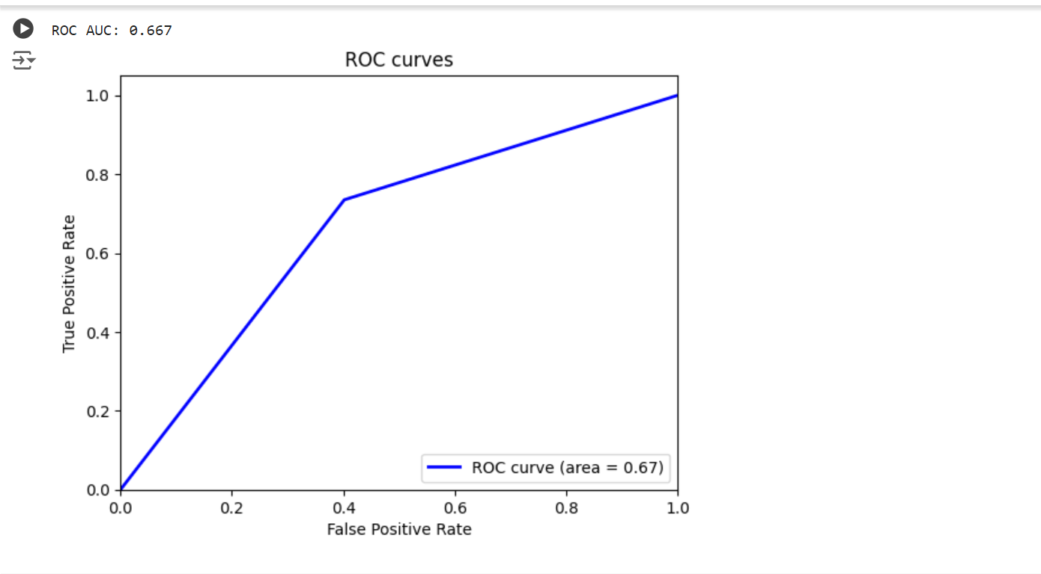

# a function given a function, it predicts the class of the image

def predict_image_class(img_path, model, threshold=0.5):

  img = tf.keras.preprocessing.image.load_img(img_path, target_size=(299, 299))

  img = tf.keras.preprocessing.image.img_to_array(img)

  img = tf.expand_dims(img, 0) # Create a batch

  img = tf.keras.applications.inception_v3.preprocess_input(img)

  img = tf.image.convert_image_dtype(img, tf.float32)

  predictions = model.predict(img)

  score = predictions.squeeze()

  if score >= threshold:

    print(f"This image is {100 * score:.2f}% malignant.")

  else:

    print(f"This image is {100 * (1 - score):.2f}% benign.")

  plt.imshow(img[0])

  plt.axis('off')

  plt.show()

predict_image_class("data/test/melanoma/ISIC_0013767.jpg", m)

predict_image_class("data/test/seborrheic_keratosis/ISIC_0012136.jpg", m)

